Analysing Housing Prices in Metropolitan Areas of India

House price prediction in a metropolitan city in India is a valuable solution for

potential home buyers, real estate agents, and investors. By leveraging

historical sales data, property details, and location-specific information, a

predictive model can accurately estimate house prices. The model's scalability,

real-time updates, user-friendly interface, and transparency ensure it meets

the needs of stakeholders. Integration capability, data privacy, and cost-

effectiveness are also important considerations. By addressing these

requirements, the prediction model provides reliable insights, empowering

stakeholders to make informed decisions in the fast-paced real estate market.

2. problem definition & design thinking

2.1 Empathy map screenshot 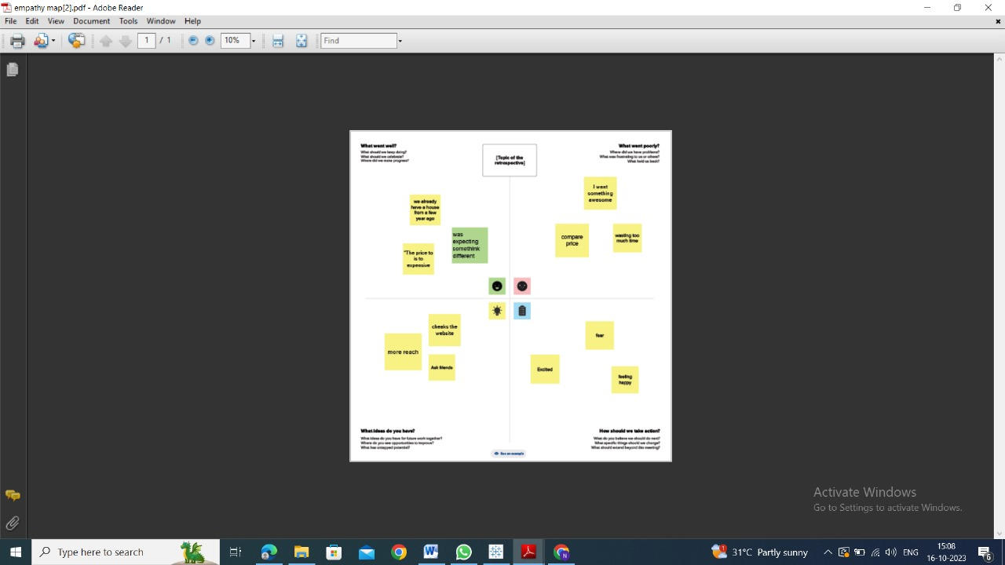

2.2)Brainstorming map screenshot

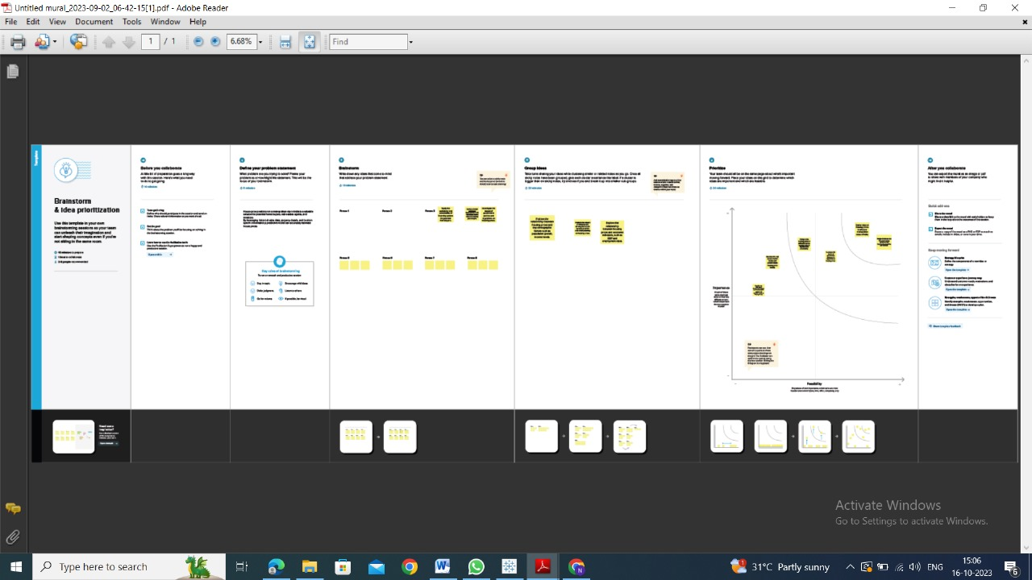

3.Result

1)Area pricing objectives shown

2)Prices of mattresses explain

3)Price geographical location describe

4)Hospital price transparency given

4.ADVANTAGES

Rental Income: Investing in metropolitan areas can provide a steady stream of rental income, as there is generally a higher demand for rental properties in cities.

Amenities and Infrastructure: Metropolitan areas offer better amenities, infrastructure, and services, making them attractive to residents and tenants.

DISADVANTADES

High Property Prices: One of the most significant disadvantages is the high cost of real estate in metropolitan areas. This can be a barrier to entry for many investors and homebuyers.

Competition: Due to high demand, there can be intense competition for properties, leading to bidding wars and inflated prices.

Traffic and Congestion: Many metropolitan areas face issues of traffic congestion and limited parking, which can negatively impact the quality of life for residents.